# PID 201 Program Loading Guide

1. Install i-TRiLOGI 7.2 build 04 software.
2. Connect the PLC to the PC using a USB cable.
3. Start up the “PID_201_GFS_Adam_7_5_4p_pump_11” program.
4. Upload the program to the PLC by clicking the UPLOAD button:

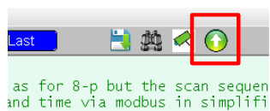

1. Click Configure Serial Port button to setup the port:

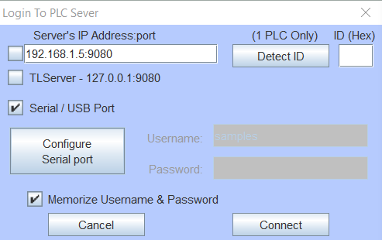

1. Select the newly added COM port (in this case is COM5), make sure the values are correct (baud rate of 38400, data bit 8, stop bits 1, parity bits none) click Open Port.

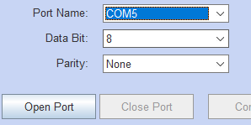

1. Click “Change ID” and in the next window, click “Detect ID” to see if it pulls back an ID number. This may take a few tries with error messages coming back. If it continues after several attempts check the comm. connections and try again.  
   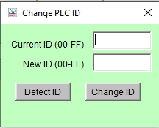 Good: 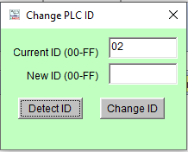 Error: 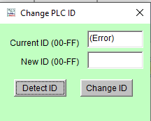  
     
   Possible Errors (IR02* is the ID being sent back by the PLC):  
   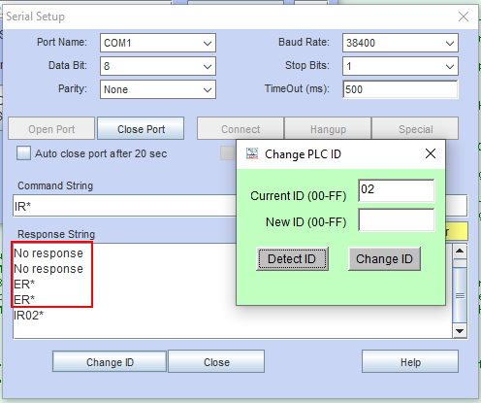

Exit the serial setup menu after this point.

1. Click the Connect button and Click Yes to transfer and overwrite PLC’s program.

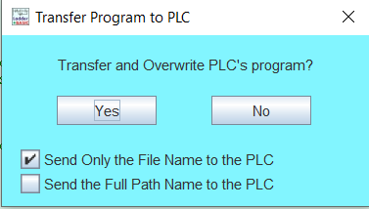

1. After the program is successfully uploaded (~2 minutes), make sure to click Reset button to reset the PLC.

# Modbus RTU Communication Report

## Connection setting:

**Serial**: COM5

**Baud Rate**: 38400

**Data Bits**: 8

**Stop Bits**: 1

**Parity**: None

**Timeout**: 3

**Device**: 1

**Function**: 03-Read Holding registers(4xxxxx)

**Offset**: 1016

**Length**: 11

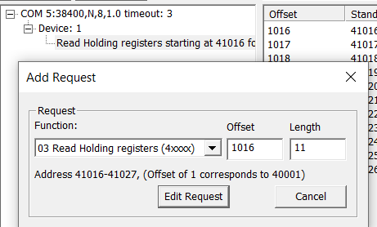

On power on, the device is in its Main (working) mode, the lamp is ON. The display shows the measured concentration of VOC in ppm. At the end of the run for given point, the data is automatically sent out via RS232 port, in Modbus RTU mode. The data is sent to the client device (SCADA or something else) as pa packet of eleven 16-bit registers, starting with the register # selected in the setup. These 11 registers hold the following info for the run through given point:

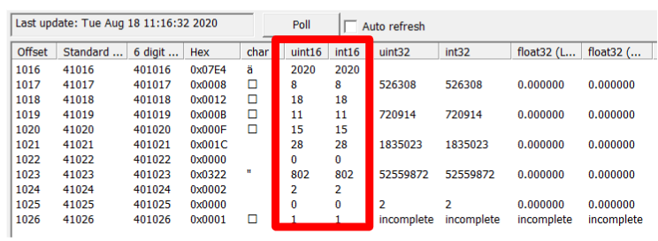

* 1st register - the year, i.e: **2020**
* 2nd register – the month, i.e: **8**
* 3rd register – the day, i.e: **18**
* 4th register – hour, i.e: **11**
* 5th register – minute, i.e: **15**
* 6th register – second, i.e: **28**

The date-time is shown: **2020-08-18 11:15:28**

* 7th holds the high two bytes, C4 C3, of the 32-bit number for concentration (in ppb),i.e: 0
* 8th register holds the low two bytes, C2C1, the 32-bit number for concentration (in ppb). Combine these two 16-bit registers into a 32-bit number, C4C3C2C1, and read it as a 32-bit number. The result is the concentration value in ppb. In that number, if read as a decimal number, move the decimal dot 3 position to the left to get the concentration value in units of ppm, with 3 decimal places after the dot, i.e: **802**.

The VOC value is: **802ppb** or **0.802ppm**

* 9th register holds the point number where the data was just collected and sent out, i.e: **2**
* 10th register holds a 16-bit number where the lowest 3 bits represents the errors as follows: bit0 = 1 indicates calibration failure; bit1 = 1 indicates that the cal gas needs to be replenished soon; bit2 = 1 indicates lamp is OFF. All the other bits are not used at this time, i.e: **0**
* 11th register holds the PID-201 ID (default is 1). You need it in case the data from not 1 but several devices is sent to your SCADA or other device that collects the data, i.e: **1**